[SPRING SERVICES (SPRING JEE)]
Scheduling:-
- Scheduling is a service used for executing a task automatically according to a define schedule.
- For example, we have a schedule for alarm service in a mobile. The alarm services executed automatically according to the given schedule.
- Spring framework gives either Jdk timer services or Quartz timer service for scheduling.
- Comparatively, Jdk timer service is not efficient. Because it can only execute a task for a fixed time interval.
- In Quartz timer service, a job schedule can be defined efficiently.
Jdk Timer Service:-
- If we want to define a task then we need to extend our class from java.util.Timer class.
- Timer class is an abstract class with one abstract method called run();. So we need to define the task in run() method.
- We can define the task in another class and we can call its method() from run() method also.
- public class MyTimerTask extends TimerTask\
{
public abstract void run()
{
-----
-----
}
}
- public class WorkerBean
{
Public void doWork()
{
……..
…….
}
}
- public class MyTimerTask extends TimerTask
{
private WorkerBean workerBean;
public void setWorkerBean(WorkerBean workerBean)
{
this.workerBean = workerBean
}
public abstract void run()
{
workberBean.doWork();
}
}
- After defining a task, if we want to add a schedule for a task then we need to configure ScheduledTimerTask class in a spring configuration file.
- To initialize the Jdk timer service, we need to configure TimerFactoryBean class.
- ScheduledTimerTask contains three properties
- period
- delay
- timerTask

- Period: is a milliseconds time interval to repeat the job again. For example, if we set 6000 as a value then the job repeated for every 6 seconds.
- Delay: is a milliseconds time for starting a job for first time.
- timerTask: is an object of TimerTask class.
- Eclipse Directory Structure:-
JdkTimerTask
src
com.satya.sprint.task
WorkerBean.java
MyTimerTask.java
default package
Main.java
applicationContext.xml
Quartz Timer Service:-
- Quartz timer service is from a third party called OpenSymphony.
- Quartz timer service uses cron expression to define schedule for a job.
- A cron expression contains 7 parts, each part is separated with a white space.
- Second (0-59)
- Minute (0-59)
- Hour (0-23)
- Day of month (1-31)
- Month (1-12) or (JAN-DEC)
- Day of Week (1-7) or (SUN-SAT)
- YEAR (2900)
- For example: 15 30 17 ? AUG FRI,SAT
- 30 09 * * ?
(* means all every day and every month)
0 30 [6-9] * * ?
[6-9] ----- range
6,7,8,9 ----- list
- 15,30,45 12 ? * [1-7]
0/20 * * * * ? ------- in every 20 seconds
- 0 18 15 AUG ? 2014 --- Job is executed 15th august 2014 at 6 pm.
0 0 * * ? JAN FRI,SAT --- On Friday and Saturday of January, at each hour job is executed.
0 0 12,14,16 * * ? --- Everyday at 12 pm, 2 pm and 4 pm job is executed.
15 30 17 * DEC ? --- Everyday of December at 5:30:15 pm job is executed.
0 [20-23] * * * ? --- On each day, at each hour for the minutes 20,21,22 and 23 job is executed.
- In the 7 parts of cron expression, 7th parth (year) is optional.
- Day of month and day of week, both are mutually exclusive. It means only one of the two can be given and other one is omitted by putting “?”.
Wednesday, August 13, 2014
- In Quartz timer service, if we want to define a task then we should extend our class from QuartzJobBean.
- QuartzJobBean is an abstract class with one abstract method executeInternal(). So we should override executeInternal() mehtod to define a task.
public class MyJobBean extends QuartzJobBean
{
@Override
public void executeInternal(JobExecutionConext ctx) throws JobExecutionException
{
…………..
}
}
- In spring configuration file we need to configure the following three things:-
- JobDetailBean
- CronTriggerBean
- SchedularFactoryBean
- JobDetailBean is to configure a job class and its data.
- CronTriggerBean is to attach a cron expression schedule for a job class.
- SchedularFactoryBean is to start the Quartz timer.
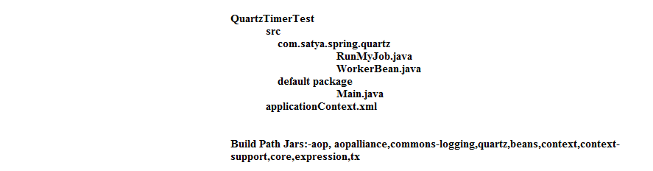
Annotation Scheduling:-
- In Spring 3.x, the framework has simplified scheduling by adding annotation @Schedule
- @Scheduled annotation is a method level annotation, it is used to define schedule for a class.
- In annotation scheduling, task can be defined in any method of any class.
- For example,
public class WorkerBean
{
@Scheduled(cron=”0 0 8 * * ?”)
public void doWork()
{
…………..
}
}
- To enable @Scheduled annotation, we need configure a tag in xml called <task:annotation-driven>.
- @Scheduled annotation has three attributes and we can pass one of the three at a time.
- @Scheduled(fixedDelay=3000) --- A job is started for next time, after 3 seconds of the completion of the previous job.
- @Scheduled(fixedRate=8000) --- A job is next time started after 8 seconds of previous job startup time.
- @Scheduled(cron=”0 0 9 * * ?”) --- A job is executed everyday at 9 am.
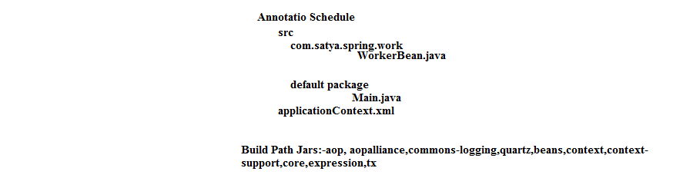
Spring Mail API:-
How E-mail works?
- Every mail server consists two servers internally.
SMTP server (outgoing server). Simple Mail Transfer Protocol
POP server (incoming server). Post Office Protocol
- If a sender and receiver of mail are in same mail server, then emails works like the following.
Diagram

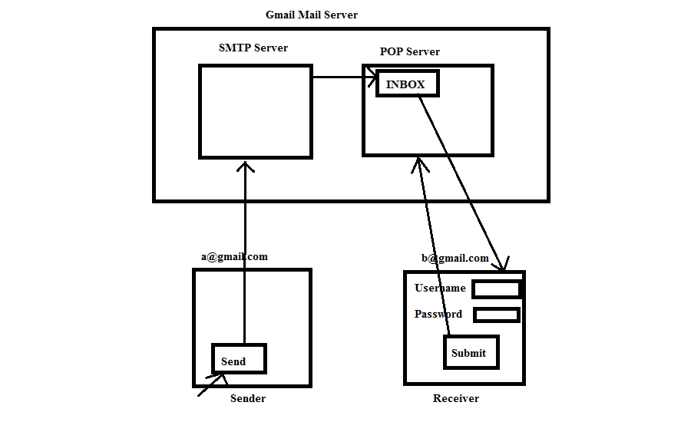
Thursday, August 14, 2014
Friday, August 15, 2014
Transaction Management:-
- A transaction is a group of operations to perform a unit of work.
- If all operations in that unit are completed successfully then a transaction becomes success.
- If anyone operation fails then all operations are cancelled of that unit and finally transaction becomes rolled-back.
- For example, purchasing a movie ticket is a transaction. If an end-user wants to book a ticket then he has to follow these below steps.
- Reserve the seat.
- Make payment.
- Issue ticket.
- Transactions are 2 types.
- Local transaction.
- Global/Distributed transaction.
- If a single resource (database) is involved in a transaction then it is a local transaction.
- If multiple resources are involved in a transaction then it becomes global transaction.
For example,
If we transfer the money between two accounts of the same bank then it is called a local transaction.
If we transfer the money between two accounts of different banks then it becomes global transaction.
In JDBC, Hibernate, EJB and Spring we can perform local transaction. But to perform distributed transactions, we must use either EJB or Spring framework.
- Every transaction must follow aquncity, consistency, isolation and durability properties.
- If once a transaction is demarcated, i.e. if we set boundary of a transaction then that transaction follows acquncity, consistency and durability properties.
- For isolation, we need to set isolation level.
- To set boundary for a transaction, we use propagation behavior.
Propagation Behaviors:-
- A propagation behavior of a transaction tells how to behave when non-transactional client is calling a transaction and when a transactional client is calling a transaction.
- Non-transactional client means there is no client side transaction exists when calling a transaction and transactional client means, a transaction exists at client side when calling a transaction.
- There are 7 types of propagation behavior.
(1)Required:-
1. If this propagation behavior is set for a transaction then it will works like the following
2. If client is non-transactional, then a new transaction begins.
3. If the client is transactional, then a transaction is also executed as a part of client transaction only.
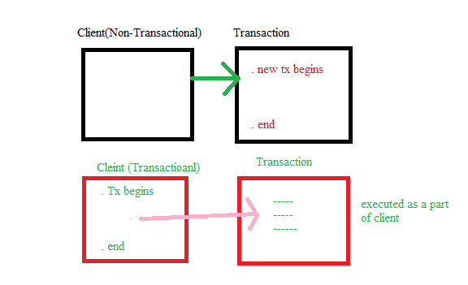
(2)Requires new:-
If this behavior set then transaction works like the following.
- If a client is non-transactional then a new transaction begins.
- If a client is transactional then also new transaction begins by suspending client transaction.
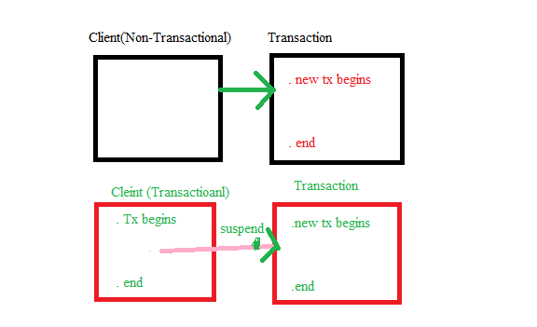

(3)Support:-
If this behavior is set then a transaction works like the following.
- If a client is non-transaction then a transaction is also executed without waiting a transaction.
- If a client is transactional then a transaction is also runs as a part of client transaction.
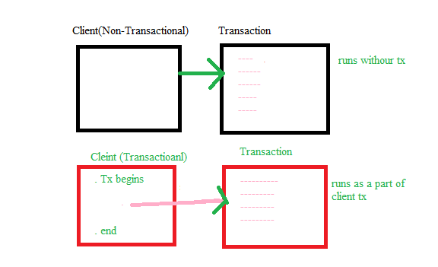
(4)Not supported:-
If this behavior is set then a transaction works like the following.
- If a client is non-transactional, then a transaction executes without transaction.
- If a client is transactional, then it is suspended and transaction executes without a transaction.
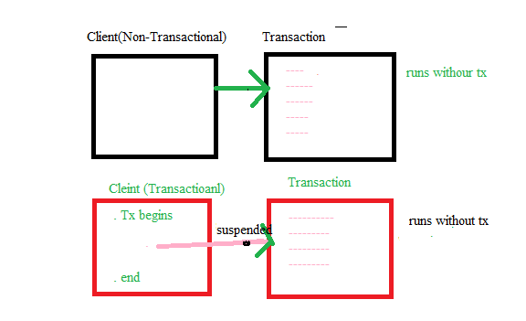
Saturday, August 16, 2014
(5)Mandatory:-
If this behavior is set for a transaction then a transaction works like the following.
- If a client is non-transactional then exception will be thrown
- If a client is transactional then a transaction is executed as a part of client transaction.
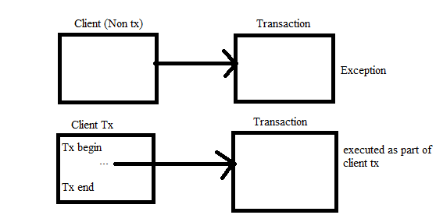
(6)Never:-
If this behavior is set for a transaction then a transaction works like the following.
- If a client is non-transactional then a transaction executed without starting a transaction.
- If a client is transaction then exception will be thrown.
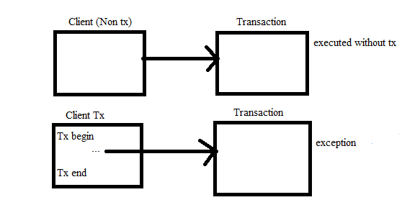
(7)Nested:-
If this propagation behavior is set for a transaction then a transaction works like the following
- If a client is non-transactional then a transaction is executed by starting a new transaction.
- If a client is transaction then a transaction executed as a nested transaction of client transaction.
- If a nested transaction is cancelled, then outer transaction also cancelled.
- If a nested transaction is committed then outer transaction will not be committed automatically
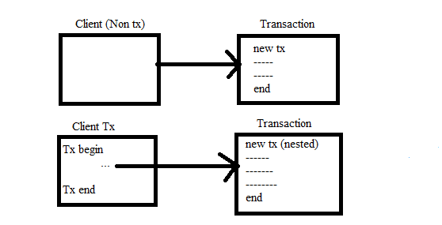
Concurrency Problems/ Isolation Problems:-
- When two or more transactions are concurrently using same set of data then concurrency problems are arise.
- There are 3 concurrency problems in transaction.
- Dirty read problem.
- Non repeatable read problem
- Phantom read problem
dirty-read problem:-
- This problems occurs when one transaction is reading the data which is updated by another transaction, before a transaction committed that data.
User Tabl
uid uname age
1 A 25
2 B 30
3 C 28

T1 T2
------------------- -------------------------------------------
------------------- -------------------------------------------
select age update user set age=35 where uid=1
from user -------------------------------------------
where uid=1 -------------------------------------------
output: -------------------------------------------
age=35 rollback
- In the above example T1 is selecting age updated by T2. So T1 got age as 35.
- When T2 is cancelled then age become 25 in database but T1 is using age as 35. Her the problem is occurred because, T1 is reading updated data of T2 before T2 is committed with commit or rollback.
Non-repeatable read problem:-
- This problem occurs, when a transaction is reading same data for twice and changes are observed in the data from previous read to current read.
- The changes are occurred, because in the middle another transaction has updated the data and committed it.
User Tabl
uid uname age
1 A 25
2 B 30
3 C 28

T1 T2
------------------- -------------------------------------------
------------------- -------------------------------------------
select age update user set age=35 where uid=1
from user -------------------------------------------
where uid=1 -------------------------------------------
output: -------------------------------------------
age=25 commit
-----------------
Select age from user
Where uid=1;
Output:
age=35
- In T1 transaction for first time age is 25 and secondly age is 35. The difference is occurred because; another transaction has updated age to 35 and committed it. So this is a non-repeatable read problem.
Phantom read problem:-
- This problem occurs, when new rows are identified in a second time read of transaction with in a given range, when compare with the previous read.
- The new rows are identified, because in the middle another transaction has inserted rows with in the given range. The extra rows identified are called Phantom rows.
User Table
uid uname age
1 A 25
2 B 30
3 C 28

T1 T2
------------------- -------------------------------------------
------------------- -------------------------------------------
select * from user insert into user values(4,’D’,27)
where age between commit
25 and 28
output:
2 rows
-----------------
Select * from use where age between 25 and 28
Output:
3 rows
- In T1 a new row identified, because in the middle T2 inserted which is matching the condition. This new row is called a Phantom row.
- To prevent concurrency problems of transaction, we have 4 isolation levels, to be set for a transaction.
Isolation Level | dirty read | non-repeatable read | phantom row read
read uncommitted
Read committed
Repeatable read
Serializable
- ----- problems not solved
- ----- problems solved

Sunday, August 17, 2014
Transaction attributes:-
- Propagation behavior, isolation level and timeout are called transaction attribute.
- Timeout attribute is to set a time boundary for a transaction
- If a transaction is not completed within the tie boundary then that transaction will be cancelled.
- The default value of timeout in spring for a transaction is -1. It means there is no time taking limit by default for a transaction of a spring.
Transaction Manager:-
- A transaction manager is responsible to begin a transaction and then to commit and rollback a transaction.
- In spring framework, we have multiple transaction manager class, which are implemented from an interface called PlatformTransactionManager.
- Based on the persistence technology used, we need to configure that transaction manager class in the spring configuration file. For example, if we use spring jdbc in a transaction, then we configure DataSourceTransactionManager and if we use hibernate persistence logic then we configure hibernate transaction manager.
Transaction Configuration:-
- Spring framework has given a special advice called transaction advice to configure attribute of a transaction.
- To add a transaction advice to a method of bean, then we use aop configuration.
Eclipse Directory Structure
TransactionTest1
src
com.satya.spring.transaction
Demo.java(I)
DemoBean.java(C)
default package
Main.java(C)
applicatonContext.xml
Refer Handout-III of Page 2&3
Jar Files in build path: aopalliance, aspectjrt, aspectjweaver, commons-logging, ojdbc14, spring-1op, spring-core, spring-beans, spring-context, spring-context-supports, spring-expression, spring-jdbc, spring-tx.
Transaction using annotation:-
- In Spring 3.x we got @Transactional annotation, it avoids transaction configuration in xml file.
- This @Transactional annotation is a method level and a class level annotation. It means we can add this annotation on top of the class.
- To enable @Transactional annotation in spring configuration file, we use <tx:annotation-driven> tag.
- Do the following changes to the above application to execute a transaction with annotation.
@Transactional(propagation=Propagation.REQUIRES_NEW, isolation=Isolation.SERIALIZABLE, timeout=5)
public void method m1()
{
-------
-------
}
- In applicationContext.xml, remove <tx:advice> and <aop:config> tag and add <tx:annotation-driven transaction-manager=”txm”/>
Same jar files required as the previous application

GLOBAL TRANSACTION
- A global transaction is a transaction which executes on multiple resources.
- In java, database connections obtained by using the implementation class of XADataSource interface, only supports global transactions.
- XADataSource is an interface of javax.sql package and its implementation class will be provide by jdbc driver vendors.
- For example, the implementation class provided by Oracle is OracleXADataSource and mysql given data source is MySqlXADataSource.
- The connections obtained with the database using implementation class of XADataSource will be stored in a connection pool. It means the connections supporting distributed transactions, also supports connection pooling.
- For distribute dtransaction management, spring framework has given a transaction manager class called JtaTransactionManager.
- JtaTransactionManager depends on a third party transaction manager which supports JTA (Javma Transaction Api).
- For example, Atomikos is a third party vendor, who provided user transaction manager (JTM), which is jta enabled transaction manager.
- Atomikos has given a class called AtomikosDataSourceBean, which created a connection pool with connections that supports global transaction. It means Atomikos data source uses an implementation class of XADataSource, to obtain connections with a database and stores in connection pool.
- In the following example, our global transaction is, transferring the money from account 1 of oracle table to account 2 of mysql table.
Eclipse Directory Structure:
GlobalTransaction
src
com.satya.spring.global
AccountInter.java(I)
AccountImpl.java(C)
default package
Main.java
applicationContext.xml
Refer PageNo.4 of Handout-III
- Before we execute global transaction application, we need to create account1 table with accno, bal cols in Oracle and account2 table with accno, bal columns in MySql databalse.
Eclipse Build Path jars: aspectrt, aspectjweaver,atomikos-transaction-api, atomikos-jta, atomikos- util, aopalliance, commons-logging, jta, mysql connector, ojdbc14,spring-aop, spring-beans, spring-core, spring-context, spring-context-support, spring-expression, spring-jdbc, spring-tx, transactions, transactions-jdbc
SPRING-JMS (Java Messaging Service)
- In java applications development, if two objects which are resided at different jvms on communicating with each other then we call the communication as remote.
- Remote communication between two objects is up 2 types.
- Synchronous communication
- Asynchronous communication
- In synchronous communication, a client object has to wait until a server object response for the request. For synchronous communication, we use technologies like RMI and EJB.
- In asynchronous communication, a client can continue the work by without waiting for the server response.
- JMS is a java API given by Sun for establishing a synchronous communication between two remote java components
Example 1,
In ATM application communication, client is ATM application, server application runs in bank. The ATM application waits until response come from bank server to withdraw money. It is a synchronous communication.
Example 2,
In a distributor to factory communication, a distributor application will send a message to factory, when stock is low. Here a distributed application doesn’t wait for the response of factory application. So the communication is asynchronous.
- JMS api consists interfaces and implementations are given by vendor jms provider. A JMS provider can be a server vendor or third-party vendor.
- In JMS communication between the client and a server takes place in the form of messages.
- In JMS, we have two messaging models,
- point-to-point model (one-to-one)
- publish-subscribe model (one-to-many)
- In point to point model a message contains only one receiver and in publish subscribe model, a message contains more than one receiver.
- In JMS, a client directly doesn’t call the server, in the middle there is a destination object will be the client and server.
- When a client send message, then it will be stored in a destination object and a receiver connects with the destination and receives message.
- In point-to-point model, a destination object is a topic and in publish subscribe model a destination object is queue.

